HISTORY 226/226W

Exploration, Science, and Adventure

Spring 2025
TR 2:00-3:15
Gavett 310

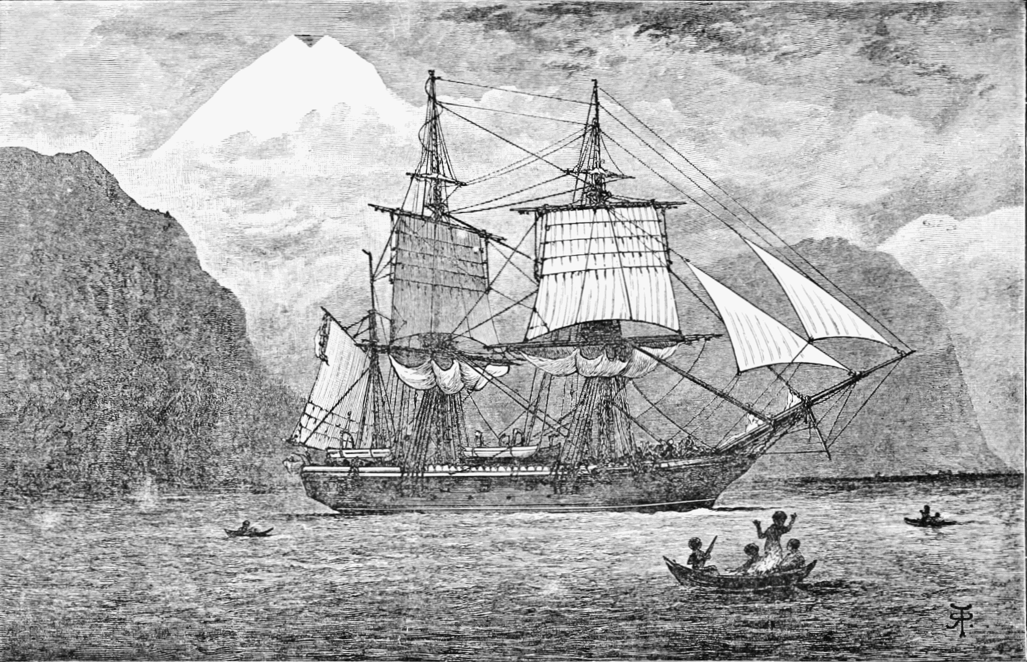

HMS Beagle in the Straits of Magellan, Monte Sarmiento, Chile

This course is a general introduction to the intersecting histories of exploration, science, and adventure from the eighteenth-century Enlightenment to the present. After a preliminary look at the idea of "exploration," what it means, and what distinguishes it from mere travel and/or adventure, we will focus each week (or two) on a discreet episode of scientific exploration, beginning with the epochal Pacific voyages of Captain James Cook concluding with the “final frontiers” of the deep seas and outer space. Other notable cases will the South American travels of Alexander von Humboldt, the transcontinental journey of Lewis and Clark, Charles Darwin’s five-year voyage aboard HMS Beagle, Robert Scott's fateful journey to the South Pole, and early scientific exploration and mountaineering in the Himalaya. Our emphasis throughout will be on the complex relation between exploration and science, and on the ways in which exploration has shaped for good and ill our modern, globally interconnected world.

The course meets twice a week for seventy-five minutes. Each week (with occasional exceptions) on Monday, I will present an informal lecture on a particular episode in the history of scientific exploration. Then, on Wednesday, we will hold an open seminar discussion of that episode based on a selection of either primary or secondary readings (or both). Attendance at both meetings, Monday and Wednesday, is essential to satisfactory completion of the course. Note that consistent attendance and participation will account for 30% of your grade in this course. Please let me know about any unavoidable absences in advance.

Instructor:

Professor Stewart Weaver, Department of History
Rush Rhees Library 368
275-9348/315-0825
stewart.weaver@rochester.edu
Office Hours: Tuesday 2:00-4:00 and by appointment

The following books are required and available for purchase at the College Town Barnes and Noble Bookstore. They are also available inexpensively on Amazon, etc. No doubt some could be read online also, but I strongly encourage everyone to read these books the old-fashioned way, on printed and bound paper. Where assimilation and comprehension are concerned, I believe there is no substitute for this ancient practice.

James Cook, Journals (978014043647)
Alexander von Humboldt, The Personal Narrative (9780140445534)
Meriwether Lewis and William Clark, Journals (9780803280397
Charles Darwin, Voyage of the Beagle (9780140432688)
Apsley Cherry-Garrard, The Worst Journey in the (9780143039389
Freya Stark, The Valleys of the Assassins (9780375757532)

The Kelly Family History Book Fund provides assistance to our undergraduate and graduate students in need to purchase books for their history courses. Students may apply for these funds using this link, https://forms.gle/c2WArDa5g696oKeU6. Following review of your application, Jacquilyn Rizzo, the History Department administrator, will contact you to let you know if we are able to assist. Please drop by the History Department office in Rush Rhees 362B.

Note that there will be some additional primary and secondary reading along the way as the syllabus indicates.

Course Requirements (226):

1. Consistent attendance and participation in class (30%)
2. Six (out of a possible 9) 2-3 page informal response papers (30%) due on the days of discussion as indicated below.
3. 12-to-15-page primary research paper (40%) due Friday, May 9

Course Requirements (226W):

1. Consistent attendance and participation in class (30%)
2. Six 2-3 page informal response papers due on the days of discussion as
indicated below (30%)
3. 15-20 page primary research paper (40%) consisting of the following three elements:
-- A 2-to-3-page proposal due the week after Spring Break
-- A rough draft of paper due Friday, May 2
-- A final draft due Friday, May 9

Statement regarding academic honesty: All students in this class will be expected to be familiar with and abide by the principles of academic honesty as laid down by the College of Arts and Science’s academic honesty policy. For the full articulation of this policy (including the consequences of its violation), see http://www.rochester.edu/college/honesty.

Statement regarding credit hours: The College’s credit hour policy on undergraduate courses is to award 4 credit hours for courses that meet for the equivalent of 3 periods of 50 minutes each week. Students enrolled in HIS 229/W are expected to devote at least one hour each week to reading and research outside of class time.

Statement regarding disability services: The University of Rochester respects and welcomes students of all backgrounds and abilities. In the event you encounter any barrier(s) to full participation in this course due to the impact of disability, please contact the Office of Disability Resources. The access coordinators in the Office of Disability Resources can meet with you to discuss the barriers you are experiencing and explain the eligibility process for establishing academic accommodations. You can reach the Office of Disability Resources at: disability@rochester.edu; (585) 276-5075.
A Note on Class Participation: This course depends on interactive lectures, presentations, class discussions, and written assignments that feed off our weekly readings. For you to learn, you need to participate consistently and stay current on all meetings and readings. Class attendance, therefore, is mandatory to your best capacity. That said, I recognize that you (or I) might need to miss one or more classes for any number of good reasons. Let me know if you need to miss a class so that we can make alternative arrangements for you to keep up with the class material.

Land Acknowledgement:

The River Campus of the University of Rochester lies within the historic homeland of the Seneca Nation, a member of the Haudenosaunee Six Nations Confederacy. It is covered by the 1794 Treaty of Canandaigua, between the United States Government and the Six Nations Confederacy, which affirmed Haudenosaunee land rights and sovereignty in the State of New York. Today, this region is still home to the Haudenosaunee people, and we are grateful for the opportunity to live, work, and share ideas in this territory.

Class Schedule

NB: This is a tentative schedule of class meetings and reading assignments as of the start of the semester. I reserve the right to make adjustments and changes as needed as we go along

WEEK I What is Exploration?

Jan. 22 Introduction and Overture

Jan. 24 Discussion 1: What is Exploration?

Reading: Stewart Weaver, Exploration: A Very Short Introduction, ch. 1 (Blackboard); Dane Kennedy, “Introduction,” in Kennedy, ed., Reinterpreting Exploration (Blackboard); Michael Robinson, “What is Exploration” (2008) and “The Birth of Exploration” (2008) from “Time to Eat the Dogs

WEEK II Exploration and the Enlightenment

Jan. 27 What is Enlightenment?

Jan. 29 Discussion 2: Exploration and Enlightenment

Reading: Dorinda Outram, The Enlightenment, Ch. 4, “Exploration, cross-cultural contact, and the ambivalence of the Enlightenment” (Blackboard); Philip J. Stern, “Exploration and Enlightenment,” in Dane Kennedy, ed., Reinterpreting Exploration (Blackboard)

WEEK III The Voyages of Captain Cook

Feb. 3 History’s Man

Feb. 5 Discussion 3: Cook’s Journals

Reading: Selections from James Cook, The Journals (TBA)

WEEK IV Enter Romanticism

Feb. 10 Alexander von Humboldt and the Invention of Nature

Feb. 12 Discussion 4: Humboldt’s Personal Narrative

Reading: selected chapters from Alexander von Humboldt, The Personal Narrative (TBA)

WEEK V Manifest Destiny

Feb. 17 Lewis and Clark and The Corps of Discovery

Feb. 19 Discussion 5: The Journals of Lewis and Clark

Reading: selections from The Journals of Lewis and Clark (1804-06); Michael Robinson, “Why We Need a New History of Exploration,” (2009)

WEEK VI The Voyage of the Beagle

Feb. 24 Charles Darwin and the Voyage of the Beagle

Feb. 26 Discussion 6: Darwin and his Legacy

Reading: selected chapters from Charles Darwin, The Voyage of the Beagle (1839)

WEEK VII The Magnetic Crusade

Mar. 3 James Clark Ross and the Magnetic Crusade

Mar. 5 John Franklin and the Search for the Northwest Passage

Reading: None. Begin work on research papers

WEEK VIII A River Runs Through It

Mar. 17 Rivers of Empire

Mar. 19 Discussion 7: John Wesley Powell and the Grand Canyon

Reading: selected chapters from Powell, The Exploration of the Colorado River and its Canyons (Blackboard)

WEEK IX The Abode of Snow

Mar. 24 The Exploration of the Himalaya

Mar. 26 Discussion 8: Joseph Hooker in the Himalaya

Reading: selections from Joseph Hooker’s Himalayan Journals (Blackboard); selections from Jim Endersby, Imperial Nature: Joseph Hooker and the Practices of Victorian Science (Blackboard)

WEEK X Geography Militant

Mar. 31 David Livingstone: Missionary of Science

Apr. 2 The Race for the Nile

Reading: None for this week. Begin The Worst Journey in the World for week XI.

WEEK XI The “Heroic Age” of Exploration

Apr. 7 Robert Scott and “The Race to the Pole”

Apr. 9 Discussion 9: “The Winter Journey”

Reading: Apsley Cherry-Garrard, The Worst Journey in the World, pgs. TBA

WEEK XII Research Papers

Apr. 14 No class: work on research papers

Apr. 16 No class: work on research papers

WEEK XIII The Last Romantics

Apr. 21 Freya Stark, Wilfrid Thesiger, and the exploration of the Middle East

Apr. 23 Discussion 10: Freya Stark and the Valleys of the Assassins

Reading: selections from Freya Stark, The Valleys of the Assassins (1934) and Wilfrid Thesiger, Arabian Sands (1959)

WEEK XIV Final Frontiers

Apr. 28 The Sea, The Sea

Apr. 30 Cosmos

Reading: None—work on papers

Friday, May 2: Rough Drafts Due (HIST 226W)

Friday, May 9: Final Drafts Due (HIST 226 and 226W)

