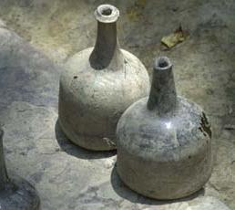
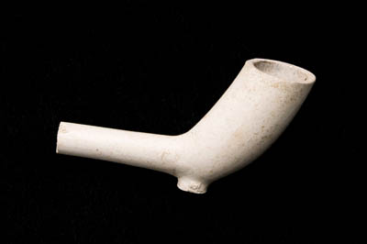
HIS 280/280W/480

Introduction to Historical Archaeology:

Field and Research Methods

Spring 2023

MW 11:50-1:05 p.m. Prof. Michael Jarvis
Rush Rhees Library 456 Office: Rush Rhees 445/455
Phone: 585-485-9870 michael.jarvis@rochester.edu
Office Hours: Tu 2:00-4:00 pm

Course Description: How do archaeologists reconstruct and interpret the past? This course introduces you to historical archaeology and uses archaeological sites and material culture to examine aspects of European expansion into the Americas. Through lectures, discussions, exercises, case studies of famous sites, independent research, and a field practicum in Bermuda over Spring Break we will examine the methods and theoretical approaches of historical archaeologists and deepen our understanding of Native Americans, Africans, Europeans, African Americans and European Americans in the early modern Atlantic World. We will especially consider how archaeologists interpret the sites and artifacts they investigate and how this contributes to our understanding of the dynamics of colonization, creolization and the emergence of new American cultures, Atlantic connections and early manifestations of globalization, and insights into the daily lives of ordinary Americans who are often poorly documented. Students in the Archaeology, Technology and Historic Structures program will have the opportunity to do original research in their own areas of interest. Although historical archaeology as a field studies Western culture through the present, this course will confine itself mainly to the early colonial/pre-industrial era and to the Anglo-Atlantic World through 1850.

I assume you have no prior knowledge of historical archaeology method or theory and a very basic understanding of early American history. Students interested in good general overviews of early American/Atlantic history are encouraged to read Alan Taylor, American Colonies (2002). Students who are already well versed in archaeology or early American history: please bear with me as I introduce basic concepts and contribute what you know to help out!

Assessment: Your grade in this class is based on attendance and class participation (30%), two written exercises (5% each), an artifact ID and interpretation practicum (10%) an in-class midterm exam on February 20 (10%), a reflection on your field experience (10%), your contribution to a final research site report that we will submit to the Bermuda Government and Bermuda National Trust due on May 3 (15%) and a take-home final exam due on May 5 (15%) . The course involves a lot of small assignments to get you to apply abstract and experiential knowledge actively throughout the semester. It also involves a lot of writing and feedback, towards the goal of making you a better, more efficient communicator.

Students taking HIS 280W/480: In addition to the work outlined above, you will EITHER edit, revise, and help lay out and format the final site report between April 26 and May 5 in consultation with me, site supervisors, and archaeology lab analysts/data managers OR identify and develop an independent research paper focused on a particular geographic region, topic, or methdological element within Historical Archaeology.
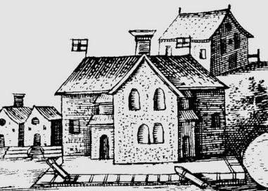
Class Participation: Through lectures, discussions, in-class activities, and a mini-field school in Bermuda during Spring Break (March 4-12, 2023), we will develop an understanding of how archaeology contributes to knowing the past, apply it in a real-world research context as we do test excavations in the cellar of the Globe Hotel, a former governor’s mansion built in 1700 owned and operated as a museum by the Bermuda National Trust. Our excavations will help date the building’s evolution and shed light on the lives of the enslaved Bermudians who lived and worked in the cellar. As we excavate, we will also process and database the artifacts we recover, which you will further analyze and interpret as you write sections of the fieldwork report we will submit to Bermudian stakeholders.

You are expected to attend every class, read the assigned material, and come prepared to ask questions and talk about what you have read. Research is by nature question-driven, so you will be expected to think on your feet. In contributing to discussion, quality is more appreciated than quantity. Be courteous and respectful to your peers. Our class is not a spectator sport: if you are silent, I will assume you are unprepared rather than brilliant but shy. I reserve the right to take pop quizzes if I suspect a significant portion of the class is not prepared, which will be factored into your class participation grade. Attendance in class is required, while attendance in the field school is strongly encouraged. It is worth 25% of your grade. After two unexcused absences, each missed class will reduce your final grade by 2%.

Students unable to participate in the Bermuda excavations will instead develop a fieldwork project focused on a local historic site, most likely the Clark House (circa 1830) in Penfield. They should be prepared to devote at least two Saturdays (or one whole weekend) to on-site observation, documentation, and analysis although this might not involve actual excavation, and undertake primary source historical research on the property’s owners and history.

UR Writing, Speaking, and Argument Center (WSAP): As you review and research papers over the course of the semester, you are certainly allowed and very much encouraged to work with writing tutors and specialists in the College WSAP, located in Rush Rhees G-122. They will help you to improve your prose and organization and can serve as ideal readers/sounding boards as you develop your research projects. As a fortune cookie I once opened stated, “Good writing is clear thinking made visible.” The writing center staff can help you to achieve this if you work with them.

Credit Hours: The College’s credit hour policy on undergraduate courses is to award four credit hours for courses that meet for the equivalent of three periods of fifty minutes each week. Students enrolled in HIS 280/280W will be satisfying the time commitment for the fourth credit through their week of fieldwork and work devoted to creating the final site report.

Rush Rhees Research Librarians: You are also encouraged to consult UR research librarians early and often while developing your papers. They can help you at all stages of the research project, especially in finding relevant source materials. You can contact them via the Reference Desk.

Students with disabilities: The University of Rochester respects and welcomes students of all backgrounds and abilities. In the event you encounter any barrier(s) to full participation in this course due to the impact of disability, please contact the Office of Disability Resources. The access coordinators in the Office of Disability Resources can meet with you to discuss the barriers you are experiencing and explain the eligibility process for establishing academic accommodations. You can email the ODR at disability@rochester.edu or call (585) 276-5075; Taylor Hall.

Academic honesty: All assignments and activities associated with this course must be performed in accordance with the University of Rochester's Academic Honesty Policy. Cheating and plagiarism are serious offenses and will be treated as such. Anyone who engages in such activities will be turned over to the College Board on Academic Honesty for disciplinary action, as outlined athttp://www.rochester.edu/College/honesty/. For a helpful discussion of plagiarism (including subtle instances), see the American Historical Association’s “Defining Plagiarism”.

Technology Failures: I find it curious how often hard drives crash right before scheduled tests and paper due dates. I am actually quite handy at data recovery (laptops and desktops). In order to get an excused extension in the event of your suffering a catastrophic computer failure, please bring your afflicted computer to my office so that I can attempt to recover your lost files or, if I can’t, to work out a reasonable extension timetable.

Readings (for purchase and/or on Blackboard):

Charles Orser, Jr., Historical Archaeology (2nd ed., 2004) [abbreviated: HA]
James Deetz, In Small Things Forgotten: An Archaeology of Early American Life (1996 ed.) [ISTF]

Additional articles and portions of books are marked * and accessible through the course’s Blackboard website. Read them in advance of the scheduled class

HIGHLY RECOMMENDED (for the artifact identification practicum):

Ivor Noel Hume, Guide to Historical Artifacts (rev. ed. 2001)

A Note on Communication: It is your responsibility to get to class on time and to submit all your work on time or early in paper form. I check my email and phone messages regularly and usually am good about responding to correct and courteously worded missives, but don’t expect instant responses and do not assume I got your email. Informal and poorly punctuated/capitalized emails annoy me. If a truly urgent or important situation arises, try to contact me in person, relay a message via the history department, or call me directly (585-485-9870) rather than trust email alone. Also, do not simply “disappear” if you find yourself overwhelmed or struggling: I can only work with you if I know this is happening, and an early timely intervention can do far more than damage control at semester’s end.

Course Schedule
* = reading on electronic reserve

Jan. 11 (W) Introduction to Archaeology, Colonization, Bermuda, the Course, and Each Other

Week I – Preparations

Jan. 16 (M) NO CLASS – MLK Day

Jan. 18 (W) NO CLASS - Instead, READ Orser, Historical Archaeology, Preface & chs. 1-3 & 11-13 and Deetz, In Small Things Forgotten, ch. 1 and TAKE EXTENSIVE NOTES on important terms and how the authors define the fields of history, archaeology, and anthropology. What makes Historical Archaeology distinctive or unique?

Weeks II-V - Digging and Thinking

Jan. 23 (M) Big Picture: Defining Disciplines: DISCUSSION of Orser & Deetz

Jan. 25 (W) Big Picture: European Global Expansion, 1450-1600 (lecture)

Jan. 30 (M) Defining Terms: Archaeological Sites, Artifacts, and Site Formation – READ Orser, HA chs. 3-4

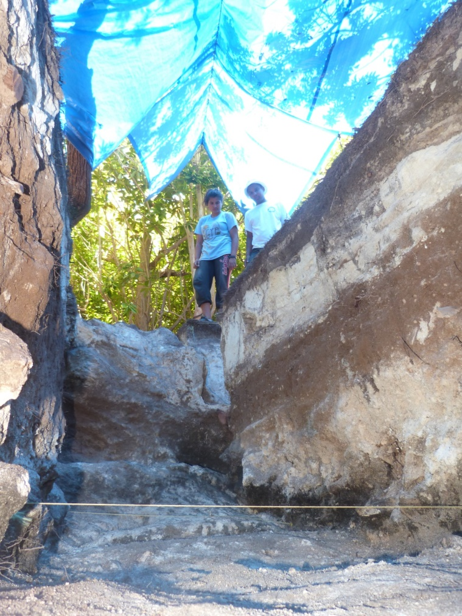
Feb. 1 (W) Medium Picture: Bermuda & St. George’s (lecture-discussion). READ Jarvis, Bermuda’s Architectural Heritage: St. George’s, 1-27, 62-64; Jarvis, Eye of All Trade, intro, chs. 1-2.

Feb. 6 (M) Historical/Archaeology - Finding Sites: historical research, remote sensing, and local knowledge – READ HA ch 6-7; “Reading Documents Archaeologically” assignment handed out

Feb. 8 (W) Excavating Sites: approaches, principles, and recording – READ HA ch 8; SIAP Field Manual

Feb. 13 (M) Interpreting and Analyzing Sites: Space and Time – READ HA ch 5, pp. 211-215
Documents assignment due; Stratigraphy Exercise assignment handed out

Feb. 15 (W) Theory and Interpretation of Sites and Cultures – READ HA 47-53, 217-236; ISTF, chs. 2 & 9; Stratigraphy Exercise due

Feb. 20 (M) - MIDTERM EXAM

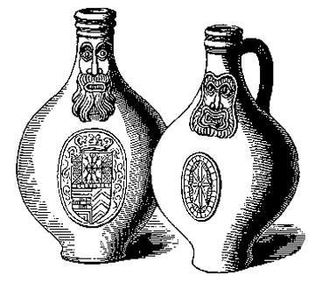
Weeks VI-VIII Fieldwork and Labwork

Material Culture: Tools of the Trade

Feb. 22 (W) Introducing Historical Artifacts I: overview and ceramics – READ - HA 110-116, 127-134; ISTF, ch 3,
* Ivor Noel Hume, Guide to Artifacts of Colonial America, pp. 102-150, 203-210, 257-265, 276-285

Feb. 27 (M) Historical Artifacts II: pipe stems, nails, bottles –

READ Hume, Guide, pp. 60-75, 252-254, 296-308

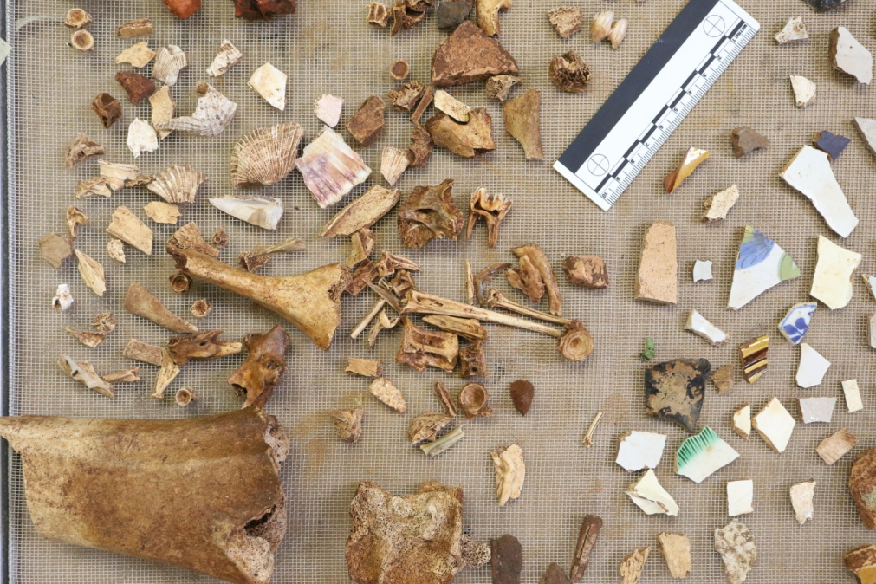
Mar. 1 (W) Preparing for the Field School – orientation to travelling to Bermuda and review of work schedule, goals, field and lab data recording procedures

SPRING BREAK FIELDWORK
(May be adjusted due to weather conditions)

March 4 (Sa) Fly from Rochester to Bermuda as a group, arrive and travel to Paget Island, Welcome dinner.

March 5 (Su) Morning: Orientation tour of St. George’s, set up lab and site equipment, prep site(s); Afternoon: survey of St. George’s vernacular architecture and landscape archaeology, individual island exploration.

March 6 (Mo) Morning: trip to Bermuda Archives, documentary research (maps, deeds, photographs, etc.) Afternoon: set up excavation units in Globe Cellar, overview of grid, mapping, and recording protocols. Late Afternoon: Tour of Smith’s Island archaeology sites (2010-2022).

March 7 (Tu) Begin Excavation. Evening: artifact processing orientation (washing, identification, sorting, bagging, database entry)

March 8 (We) continue excavations; Evening: artifact processing
March 9 (Th) continue excavation. Afternoon: common meeting to assess progress
March 10 (Fr) Morning: excavation. Afternoon: attend Virtual St. George’s student presentations.
March 11 (Sa) EITHER Free time/visit to Dockyard and West End Beaches or Return to Rochester (TBD by individual students)
March 12 (Su) Rest of students return to Rochester
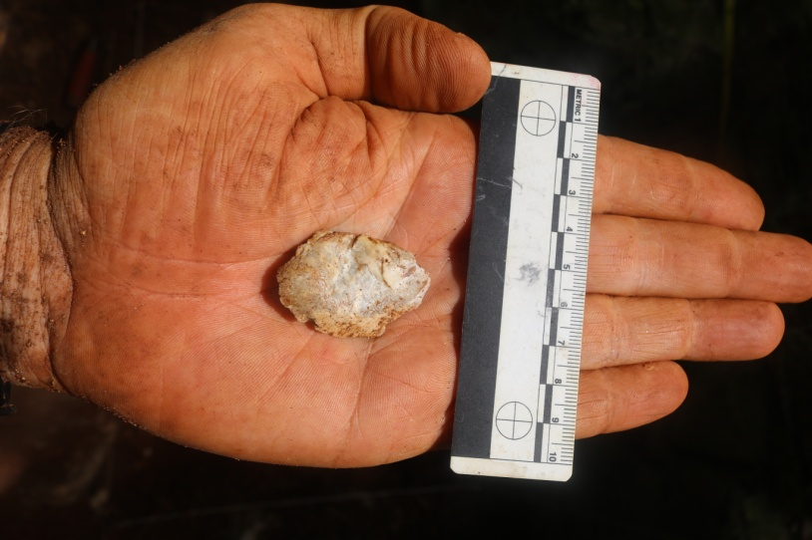
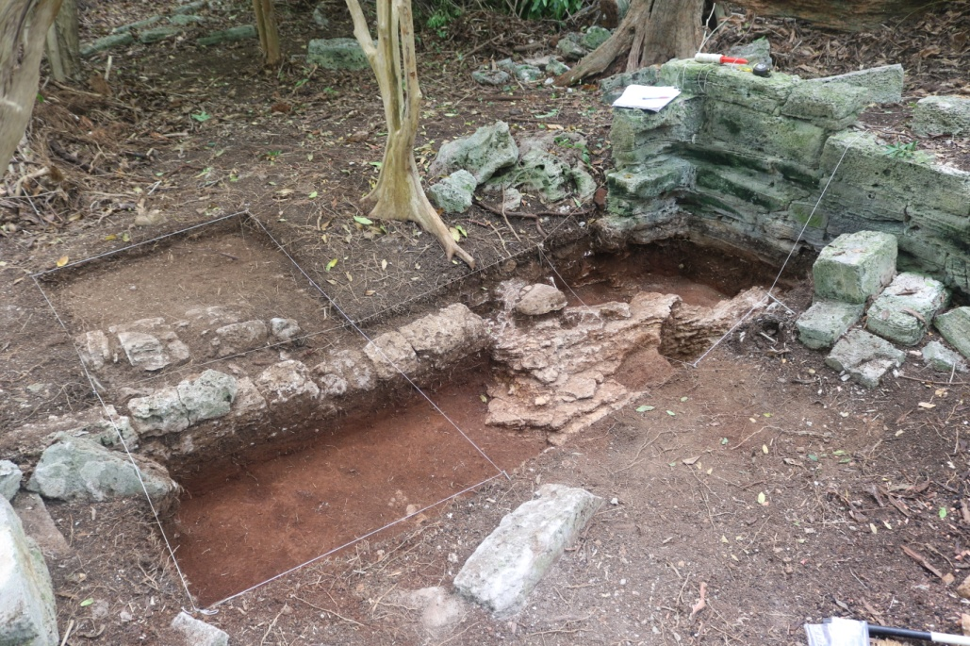
Mar 13 (M) NO CLASS – – recover from Field School and catch up on your other work & write your assessment/reflection on your fieldwork experience.

Mar 15 (W) – Assessment of fieldwork, Design Field Report, and assign student roles in producing the report, including additional contextual discussion and further research).
*** Reflection Essay on Bermuda Fieldwork DUE

Weeks X-XI
Material Culture & Site Interpretation, Continued.

Practicum on Artifact Identification and Analysis: Rush Rhees Reserve: You will work in pairs to analyze and interpret a set of hypothetical artifact assemblages.

Mar 20 (M) Faunal Remains, Ecofacts, human burials, and gravestones – READ HA 82-84, 136-137, 197-199, 261; ISTF ch. 4

March 22 (W) Households and Architecture – READ HA 138-140, 184-188; ISTF, ch 5

March 27 (M) Houses, Gardens, and Landscapes - READ HA 47-48, 140-147; *Upton, “White and Black Landscapes”

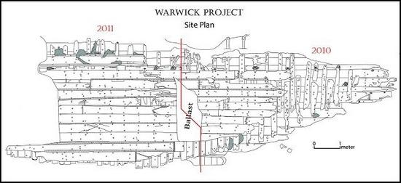
March 29 (W) Underwater Archaeology: Research, Sites, and Methods – READ HA 86-87, 163-166, 280-283; Joe Flatman and Mark Staniforth, “Historical Marine Archaeology”; Schmidt and Mrozowski, “Documentary Insights into the Archaeology of Smuggling”; Donny Hamilton, “Pirates and Merchants: Port Royal, Jamaica” and see his Port Royal Project website (http://nautarch.tamu.edu/portroyal/)
*ARTIFACT IDENTIFIECTION & ANALYSIS ASSIGNMENT DUE

Weeks XII-XIII – Historical Archaeology Case Studies

Apr 3 (M) Archaeology of Colonization, Capitalism and Globalization – READ HA 70-72, 107-110, 233-236, 264-267; * Little, “Colonialism, Capitalism, and Slavery”; * Deagan, “Historical Archaeology’s Contributions to our Understanding of Early America”

April 5 (W) European Contact and Indigenous Peoples – READ HA 169-170, 262-263, 277-279
*Alan Taylor, “Natives,” 3-22, 38-49; *Merrill, “The Indians’ New World,” * Deagan “Archaeology of Spanish Contact,” 187-205; * Clark Larsen, “Bioarchaeology of the Spanish Missions”
Exercise #3 due

April 10 (M) Frontier Sites I: Spanish America - READ HA 267-283; * Deagan “Archaeology of Spanish Contact,” 205-233.

April 12 (W) Frontier Sites II: Jamesown – READ * Little, “Survival at Jamestown” & spend at least 1 hour exploring the Jamestown Rediscovery website (Fieldwork 1994-present): https://historicjamestowne.org/
BRIEF PRESENTATION ON INDIVIDUAL WORK ON FINAL SITE REPORT PROGRESS

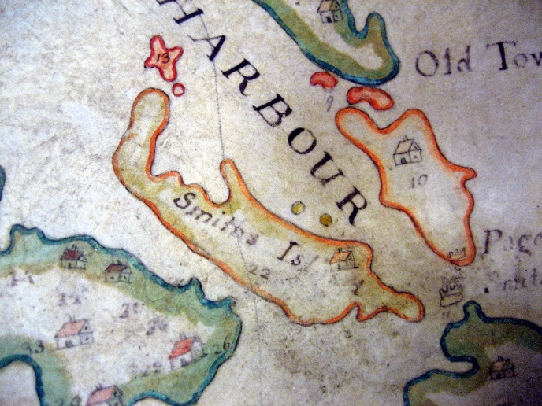
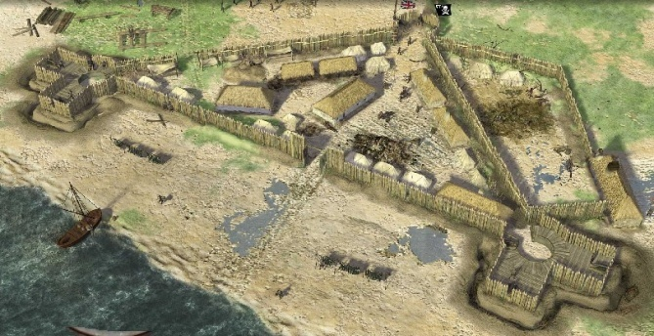
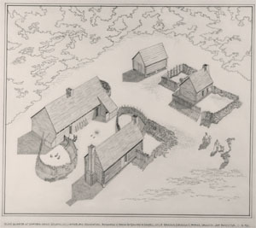
Weeks XIV-XV – Race and Nationalism

April 17 (M) Race, Slavery and African-American Archaeology – HA 260; ISTF ch.7-8;

* Lange and Handler, “Ethnohistorical Approach to Slavery”
April 19 (W) Becoming British: Replication, Adaptation, Creolization, Acculturation – HA 115-116, 226-236; * Willie Graham et. al. “Adaptation and Innovation/17th century Chesapeake,” * Wheaton and Garrow, “Acculturation . . . in the Carolina Lowcountry”

April 24 (M) Consumer and American Revolutions: The Georgian Order and its critics – ISTF ch. 6; * T.H. Breen, “An Empire of Goods”; * Orser, “From Georgian Order to Social Relations”

April 26 (W) Becoming American: Archaeological Reflections of the Early Republic
STUDENT PORTIONS OF FINAL FIELDWORK REPORT DUE

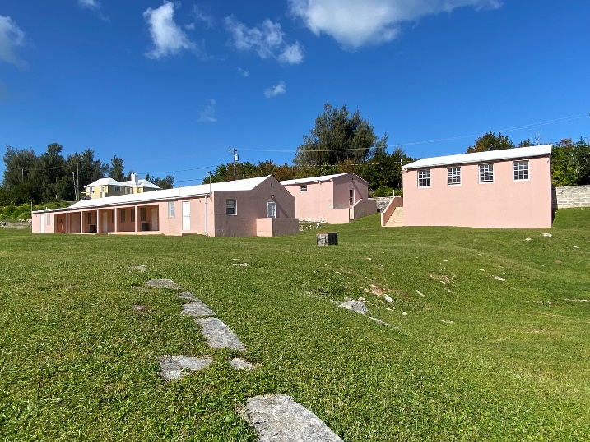
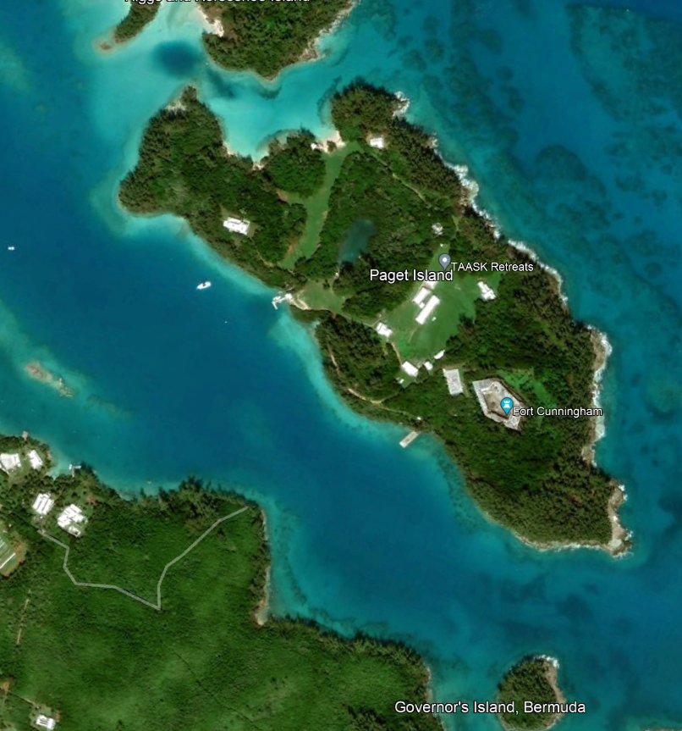
May 5 (Fri.) FINAL EXAM & Post-exam Debrief and Party

Recommended Further Reading:

Students interested in doing an optional final research paper or learning more about particular topics in Historical Archaeology and material culture should start with Orser’s bibliography (Historical Archaeology, 319-339).

For article literature, see:
Historical Archaeology (U.S.)
Post-Medieval Archaeology (British/global)
International Journal of Historical Archaeology (U.S.)
Winterthur Portfolio (material culture, decorative arts, art history)
See also Australasian Journal of Historical Archaeology and Bermuda Journal of Archaeology and Maritime History, International Journal of Nautical Archaeology

Among the works listed by Orser, see especially:
Mary Beaudry, ed., Documentary Archaeology in the New World (1988)
Amanda Bowens, ed., Underwater Archaeology: The NAS Guide to Principles and Practices (2009)
Anne-Cantwell and Diana Wall, Unearthing Gotham: The Archaeology of New York City (2001)
John Cherry & Krysta Ryzewski, An Archaeological History of Montserrat in the West Indies (2020)
Christopher DeCorse, An Archaeology of Elmina (rev. 2022)
James Deetz, Flowerdew Hundred: The Archaeology of a Virginia Plantation, 1619-1864 (1993)
Charles Ewen, From Spaniard to Creole: The Archaeology of Cultural Formation at Puerto Real, Haiti (1991)
Paul Farnsworth, ed., Island Lives: Historical Archaeologies of the Caribbean (2001)
Leland Ferguson, Uncommon Ground: Archaeology and Early African America, 1650-1800 (1992)
Andrea Frohne, The African Burial Ground in New York City: Memory, Spirituality & Space (2015)
Richard Gould, ed., Shipwreck Anthropology (1983)
Richard Gould, Archaeology and the Social History of Ships (2000)
Martin Hall and Stephen Silliman, eds., Historical Archaeology (2006)
Dan Hicks and Mary Beaudry, eds., Cambridge Companion to Historical Archaeology (2006)
William Kelso, Kingsmill Plantations 1619-1800 (1984) & Jamestown: The Buried Truth (2007);
Mark Leone and Parker Potter, eds., Historical Archaeologies of Capitalism (1999)
Charles Mann, 1491: New Revelations of the Americas Before Columbus (2005)
Ivor Noel Hume, Historical Archaeology: A Comprehensive Guide (1969); Martin’s Hundred (1991 ed.)
Deborah Rotman, Historical Archaeology of Gendered Lives (2009)
Robert Blair St. George, ed., Material Life in America, 1600-1860 (1988)
Robert Schuyler, Historical Archaeology: A Guide to Substantive and Theoretical Contributions (1978)
Paul Shackel, Paul Mullins and Mark Warner, eds., Annapolis Pasts (1998)
Carmel Shrire, Historical Archaeology in South Africa (2014)
Theresa Singleton, ed., The Archaeology of Slavery and Plantation Life (1985)
Samuel Wilson, Hispaniola: Caribbean Chiefdoms in the Age of Columbus (1990)
Anne Yentsch, A Chesapeake Family and their Slaves (1994)

Recommended Websites:

Historical Archaeology:

ArchNet – archnet.asu.edu

Society for Historical Archaeology (SHA) – www.sha.org

Council for NE Historical Archaeology& links – www.smcm.edu/Academics/soan/cneha/LINKS.HTM

Colonial Williamsburg Foundation (VA) – http://research.history.org/Archaeological_Research.cfm

Jamestown Rediscovery (VA) – https://historicjamestowne.org/

St. Mary’s City (MD) – www.stmaryscity.org/

Plimoth Plantation (MA) – www.plimoth.org/archaeology/archaeol.htm

Old Fort Niagra (NY) – www.oldfortniagara.org/arch.htm

Port Royal Project (Jamaica) – http://nautarch.tamu.edu/portroyal/

Aerial Surveys and Archaeology – www.univie.ac.at/Luftbildarchiv/intro/aa_aaint.htm

Underwater Archaeology – www.pophaus.com/underwater/ and www.nps.gov/scru/home.htm
African Diaspora Archaeology – http://www.diaspora.uiuc.edu/newsletter.html
Association for Gravestone Studies – www.gravestonestudies.org
Ceramics Digital Type Collections - http://www.flmnh.ufl.edu/histarch/gallery_types/
http://www.jefpat.org/diagnostic/index.htm
http://www.museumoflondon.org.uk/ceramics/ (and glasswares)

